VuTienDat-HE186351
Lab 1 – Setting Up Flutter and Running Your First App
1. Objective
This lab helps students set up the Flutter environment and run their first Flutter application. Students will learn how to install tools, create a project, execute it on a device/emulator, and perform basic UI customization.
2. Requirements
Students must:
- Install Flutter SDK
- Configure IDE (Android Studio or VS Code)
- Create and run a Flutter app
- Customize the layout
- Submit screenshots as evidence
3. Guided Steps
Exercise 1 – Flutter Environment Setup
Goal: Install and verify Flutter tools.
Steps
- Install Flutter SDK.
- Add Flutter to PATH.
- Run:
flutter doctor
- Ensure all items are properly configured.
- Verify Flutter & Dart plugins in Android Studio.
Deliverables
- Screenshot of flutter doctor
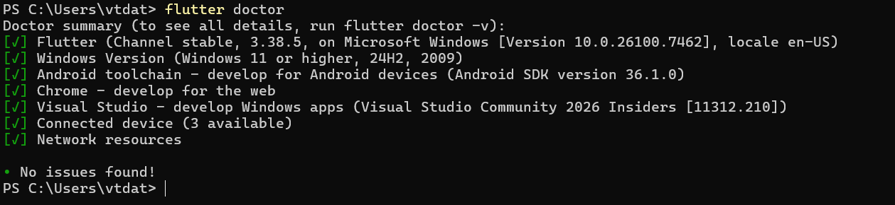
- Screenshot of Flutter/Dart plugin screen
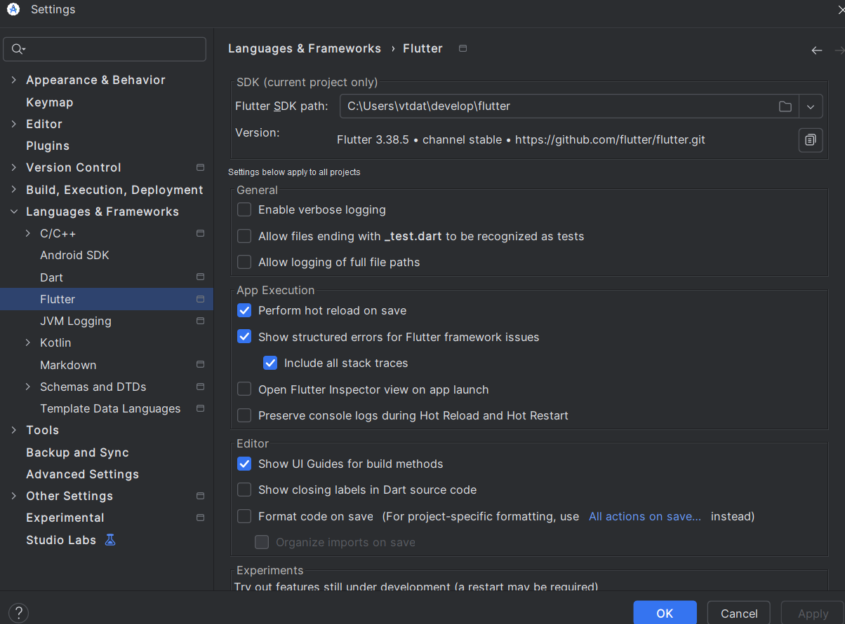
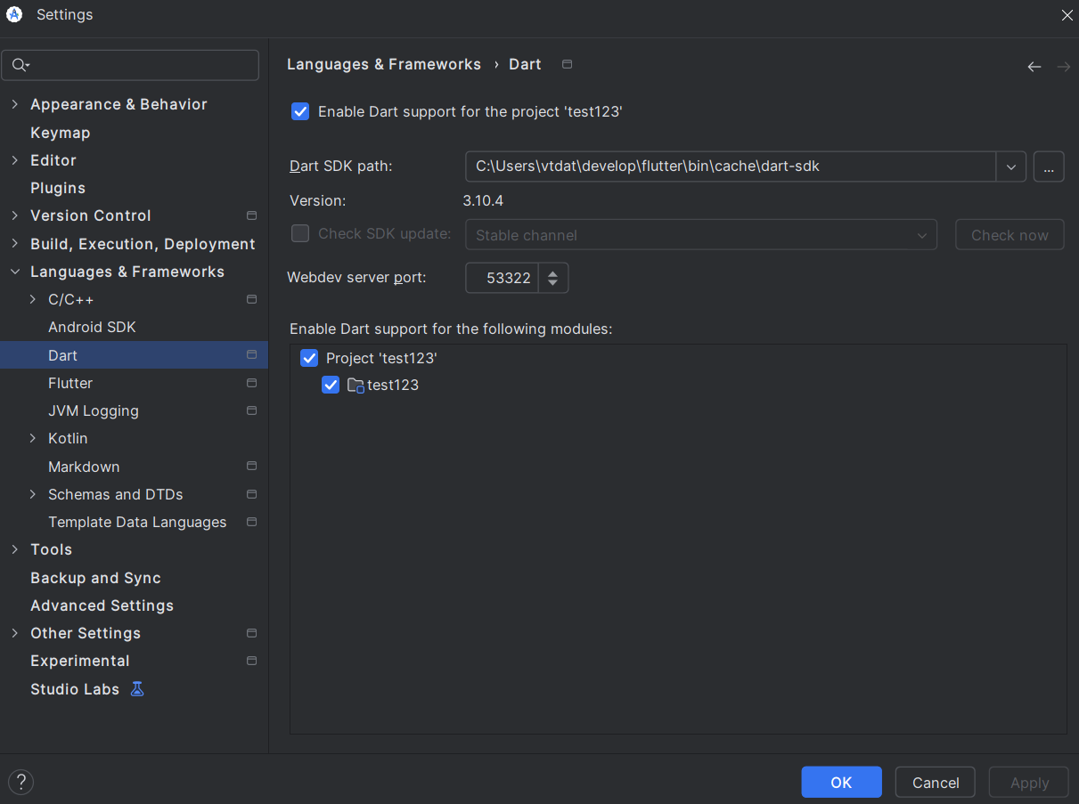
Exercise 2 – Create and Run Your First Flutter App
Goal: Learn how to create a Flutter project and run the default app.
Steps
- Open Android Studio → New Flutter Project
- Use project name: hello_flutter_lab1
- Explore key folders: lib/, android/, ios/, pubspec.yaml
- Start emulator or connect device
- Run the default counter app
- Modify the AppBar title in main.dart:
title: 'My First Flutter App',
- Use Hot Reload and observe changes
Deliverables
- Screenshot of project structure
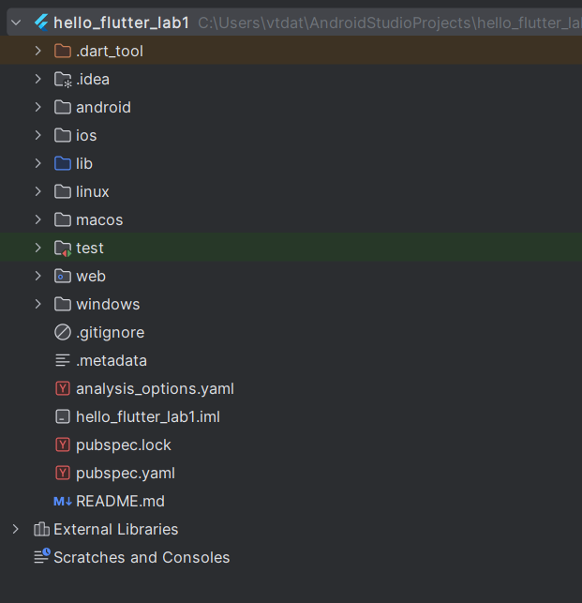
- Screenshot of running counter app
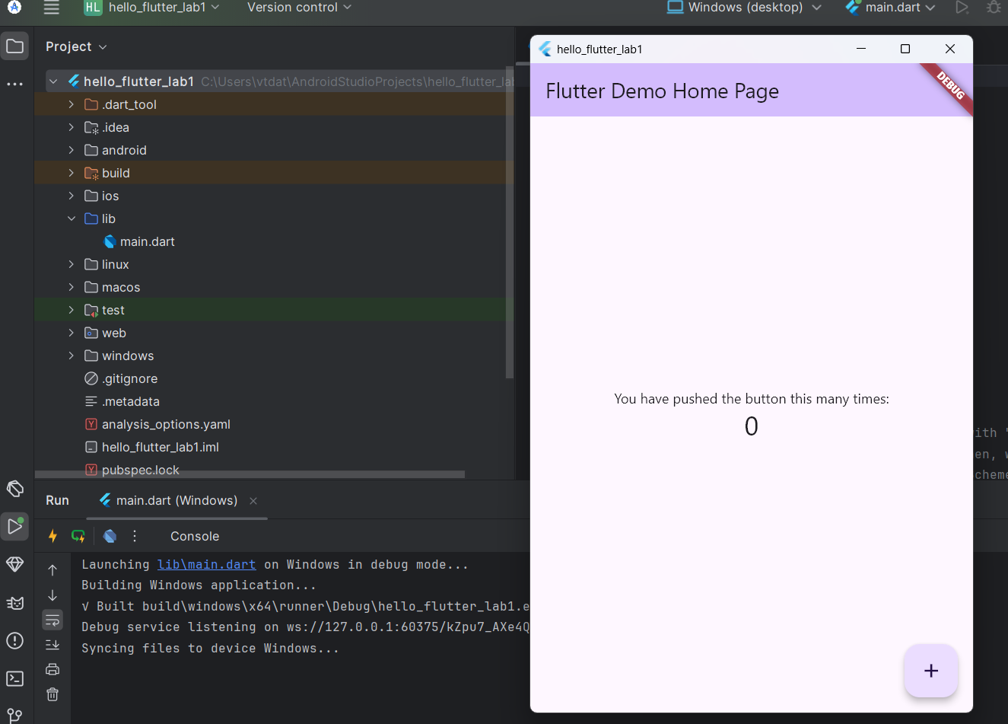
- Screenshot showing updated title via Hot Reload
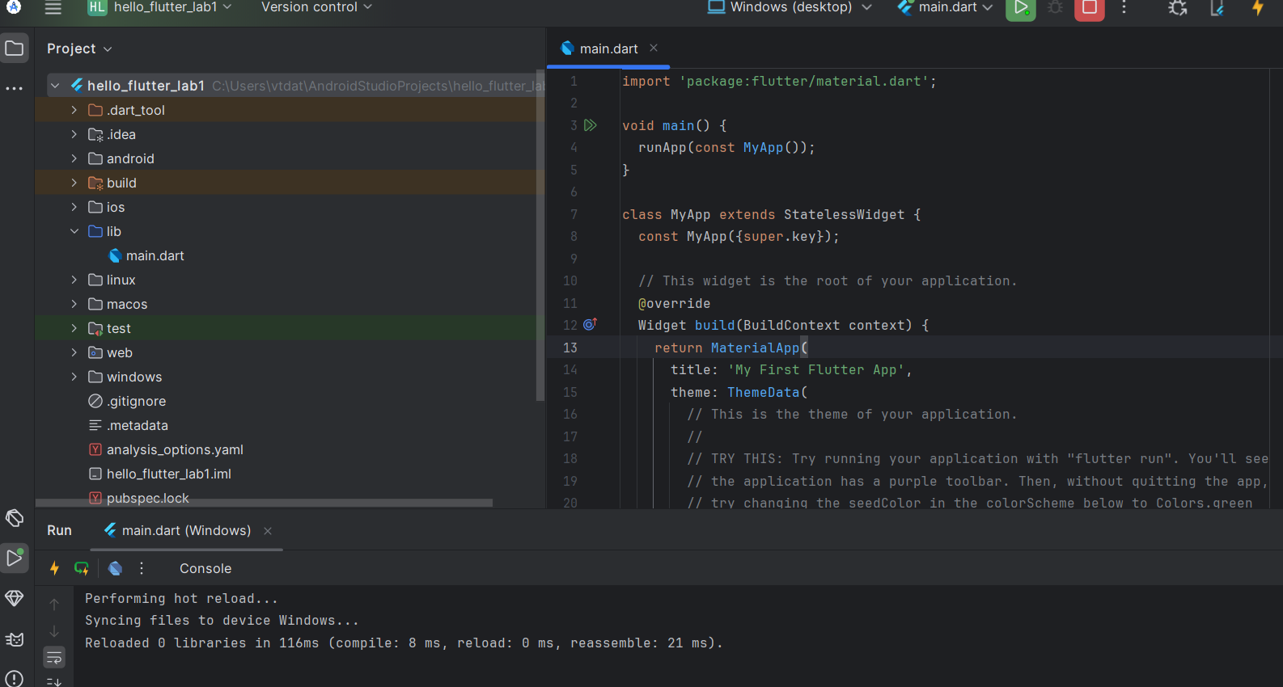
Exercise 3 – Customize Your First Flutter UI
Goal: Build a simple custom UI with widgets learned in class.
Steps
- Replace default code in main.dart with:
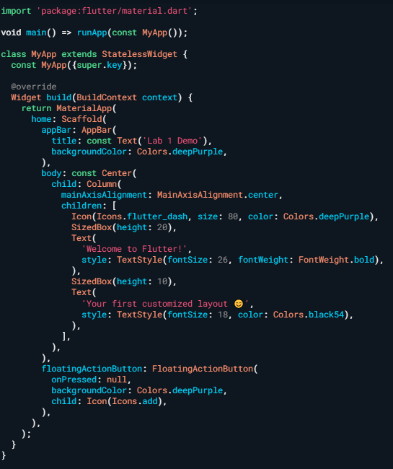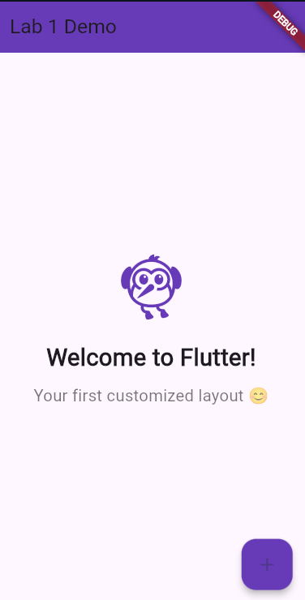
- Perform Hot Reload and verify UI updates.
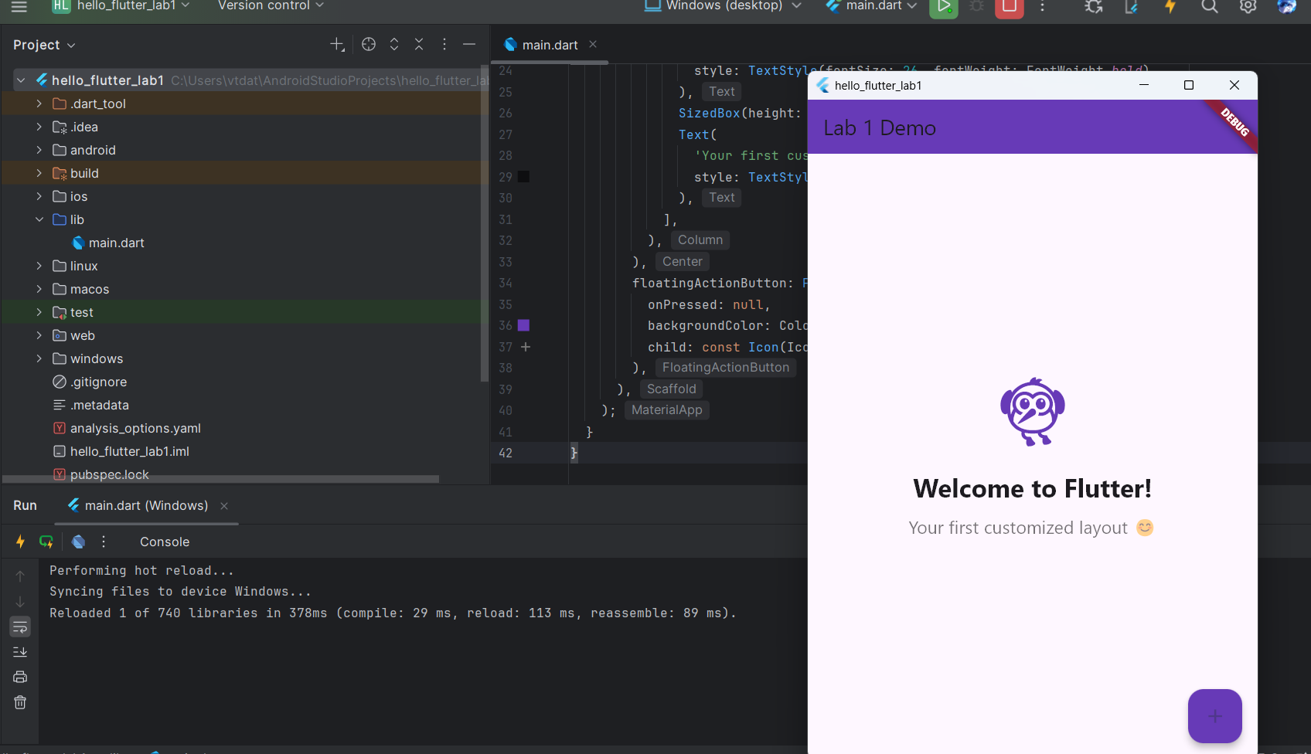
- Modify colors/text and reload again.
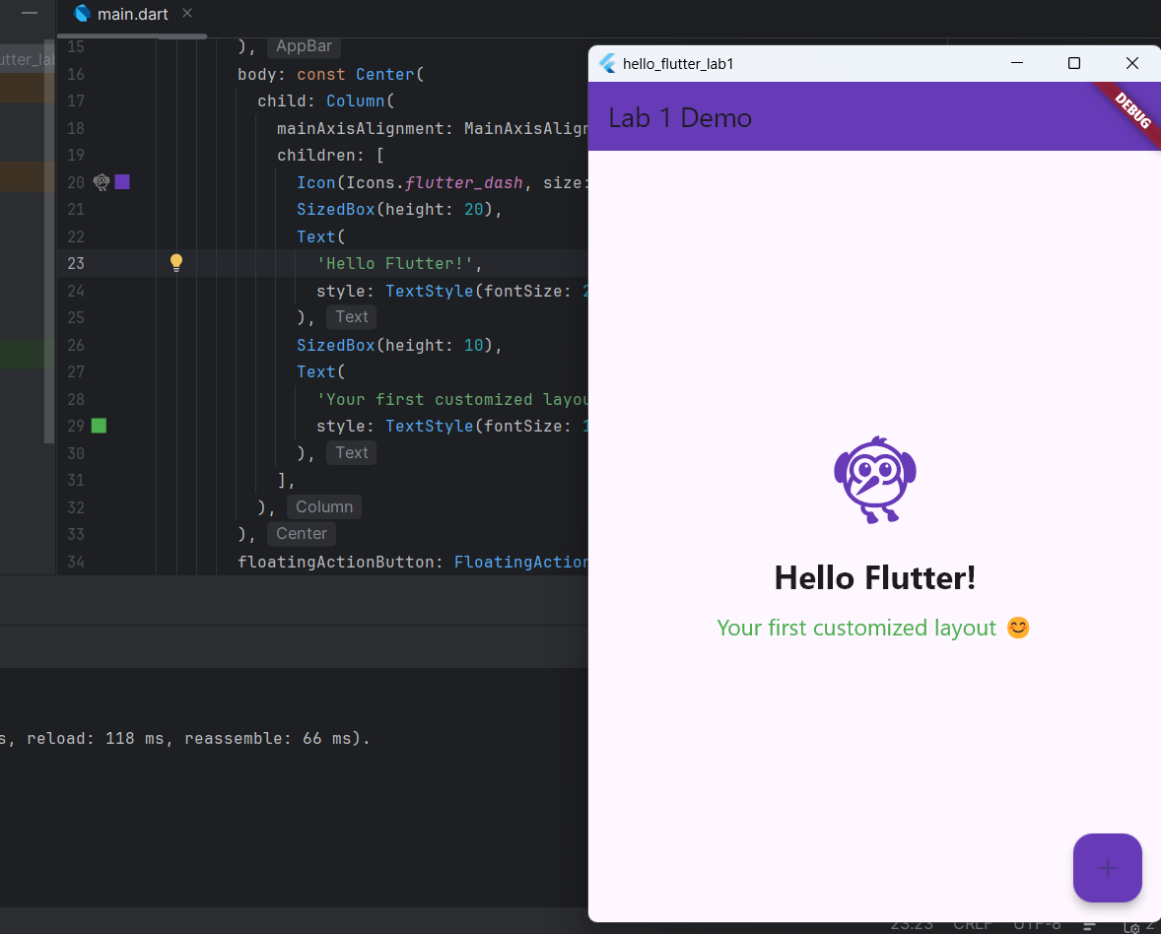
Exercise 4 – Reflection Questions
- What is the purpose of the flutter doctor command?
flutter doctor is used to check whether the Flutter environment is correctly installed and configured. It identifies missing dependencies and provides instructions to fix them.
- What file acts as the entry point of a Flutter application?
main.dart
- Explain the difference between Hot Reload and Hot Restart.
Hot Reload updates the UI instantly without losing the app state.
Hot Restart restarts the entire app and resets the state.
- How does runApp() build the widget tree?
runApp() takes a widget and makes it the root of the widget tree, rendering the UI on the screen.
- Describe how Flutter’s architecture enables cross-platform development.
Flutter uses a single codebase and renders UI using its own rendering engine, allowing apps to run consistently on multiple platforms such as Android and iOS.
4. Expected Results
- Successful setup of Flutter environment
- Ability to create and run Flutter projects
- Understanding of widgets, layout, and hot reload
- Complete screenshots for all required steps

5. Submission
- Zipped Flutter project folder or GitHub link
- All screenshots
- Written answers for reflection questions
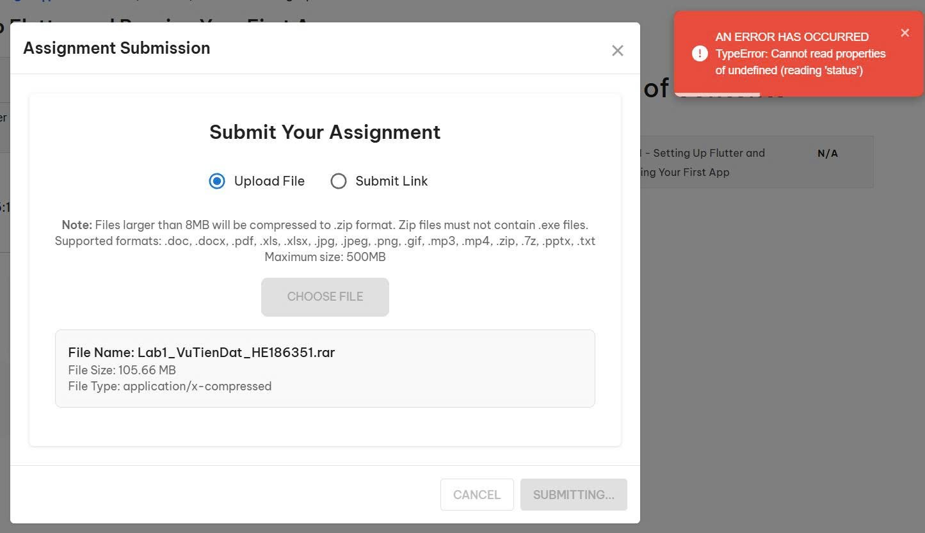
Vì không nộp được file Zip nên em nộp file docs này kèm vs link github ạ
https://github.com/DatVT04/PRM393_Lab

